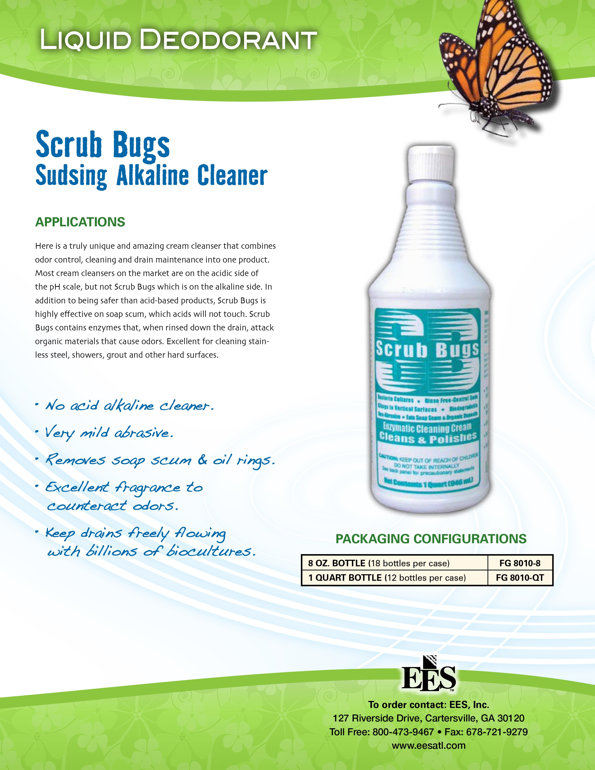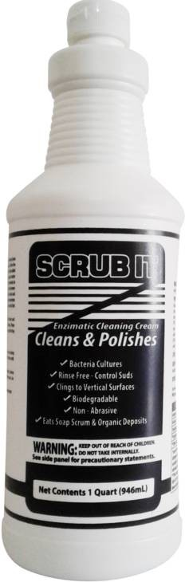

SCRUBIT

Safety Data Sheet

Product and Company Identification Product Identifier
Product Name:

SCRUBIT
Version 2.1 Revision Date: 01/31/2017

General Use: Cream Cleanser that also provides odor control and drain maintenance

Recommended/Restricted Use

Identified Uses:

Restrictions:

Distributor
P and C
Building 35 Unit 3
A mildly abrasive alkaline enzyme cleaner that removes soap scum, dissolves oily and organic materials that cause odors, cleans stainless steel, showers, grout, and other hard surfaces while providing an excellence fragrance to counteract odors.
N/A

Tonique Darling Hwy
Nassau, Bahamas

Emergency Contact Information
Phone Number: 242-364-3505
/ 242-427-4923
Company Name: P and C Supplies

Hazard Identification
GHS Classification:
Skin corrosion / irritation Eye damage / irritation Sensitization - skin

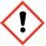
GHS Label Elements, Including Precautionary Statements Pictogram:

Category 2 Category 2A Category 1

Signal Word: Warning Hazard Statement(s):
H315 Causes skin irritation
H317 May cause an allergic skin reaction
H319 Causes serious eye irritation

Precautionary Statements:
Prevention:
P261 Avoid breathing dust / mist / spray.
P264 Wash face, hands and any exposed skin thoroughly after handling.

P272 Contaminated work clothing should not be allowed out of the workplace.

P280 Wear protective gloves / protective clothing / eye protection / face protection when using this product.

Response:
Eyes:

Skin:
P305 + P351 + P338 IF IN EYES: Rinse cautiously with water for several minutes. Remove contact lenses, if present and easy to do. Continue rinsing.
P337 + P313 If eye irritation persists: Get medical advice / attention.

P302 + P352 IF ON SKIN: Wash with plenty of water / soap.
P333 + P313 If skin irritation or a rash occurs: Get medical advice/attention. P362 + P364 Take off contaminated clothing and wash before reuse.

Storage:
P403 + P233 Store in a well ventillated place. Keep container tightly closed.

Disposal:
P501

HMIS Classification:
Health Hazard: 2
Flammability: 0
Physical Hazards: 0

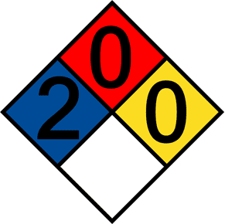
NFPA Rating:
Health Hazard: | 2
Fire: | 0
Reactivity Hazard: | 0

Use Personal Protection from Chemical and Physical Hazards.

Other Hazards:
Keep out of reach of children.
Store this product in a cool, dry place.

Composition/Information on Ingredients
Chemical Name | Weight % | CAS Number
Sodium dodecylbenzene sulfonate | 1 - 10 | 25155-30-0
Alcohols, C9 - C11, ethoxylated | 1 - 10 | 68439-46-3
Trisodium phosphate | 1 - 10 | 7601-54-9
Fragrance* | < 5 | ---
Other components** | --- | ---
*This product contains a fragrance which may contain in excess of 0.1% natural allergen or sensitizer. Some individuals who have been previously exposed and sensitized to the allergen may exibit allergic reactions or other related illnesses when re-exposed.
**This compound is a trade secret in accordance with provision 1910.1200 of the title of US Code Federal Regulations. The exact
composition of this formulation has been withheald as a trade secret.

- First Aid Measures
Description of First Aid Measures
General: Show this safety data sheet to the doctor or medical contact in attendance. Immediate medical attention is required, particularly in the case of eye contact.
Inhalation: Not a normal route of exposure. Dust residues will increase the likelihood of inhalation exposure. If breathing is difficult, remove to fresh air and keep at rest in a position comfortable for breathing. If symptoms persist or worsen, call a physican or obtain medical attention.

Skin Contact: Wash hands or exposed skin with plenty of soap and water for an extended period of time (at least 3
- 5 minutes and until any "slippery" feeling is not detected). Remove any contaminated clothing and wash it before reuse. If skin irritation, rash, or allergic reaction occurs seek medical advice and/or treatment.
Eye Contact: Rinse cautiously with water for several minutes. Remove contact lenses, if present, and continue rinsing with eyes wide open for at least 15 minutes. Do not rub affected eyes, repeat if necessary, immediately obtain medical advice / attention.
Ingestion: Not a normal route of exposure. Remove any solid material from mouth or throat. Rinse mouth with water if conscious, alert, and not convulsing. DO NOT induce vomiting. Give several glasses of water to drink. Contact a POISON CENTER / hospital / physician immediately for medical advice or treatment if you do not feel well.

Most Important Symptoms/Effects
Inhalation Not a likely route of entry. If created, dusts of this product may cause irritation to the nose, throat, and respiratory tract resulting in a burning nostril or mucous membrane sensation.
Skin Contact Skin irritation, itching or burning sensation. A slippery sensation may occur as washing skin.

Eye Contact Redness, watering, itching, or severe burning sensation of eyes.
Ingestion Not a likely route of entry. May cause stomach distress resulting in nausea, vomitiing, difficulty swallowing. A fragrant smell to breath.

Indication of Immediate Medical Attention or Special Treatment Needed:
If the above first aid measures are not successful, if there is any eye exposure, difficulty breathing, or generally feeling unwell, contact a POISON CENTER / Hospital / Physician for medical advice / attention immediately.

Note to Physician:

- Firefighting Measures

Treat symptomatically based on judgement of attending physician.

Suitable Extinguishing Media Use water, spray alcohol resistant foam, dry chemical, or carbon dioxide.

Unsuitable Extinguishing Media N/A
Specific Hazards Arising from the Chemical Combustion Products: VOCs; Carbon dioxide; carbon monoxide;
and irritating oxides of sulfur, sodium, and phosphorous.

Special Protective Actions for Firefighters

Explosion data:

Wear full protective gear clothing including a self-contained, positive pressure, breathing apparatus (SCBA) approved by NIOSH.

Sensitivity to Mechanical Impact: No
Sensitivity to Static Discharge: No
- Accidental Release Measures (Large bulk releases):
Personal Precautions, Protective Equipment and Emergency Procedures:
Keep unnecessary personnel away. Provide good ventilation to area. Wear rubber or Latex gloves and personal protective equipment ( including protective goggles or wrap around face shield) as reqired when handling this product. Evacuate personnel to safe areas. Avoid contact with skin, eyes, or clothing. Irrigate eyes, wash hands / skin immediately and/or change clothes as needed if any signs of exposure appear (i.e., itching, burning sensations).

Environmental Precautions:

Avoid discharge into lakes, streams, ponds, sanitary sewers, runoff waters, public waters, or public water systems.

Methods and Materials for Containment and Cleaning Up:
Before attempting to clean up refer to hazard data given on this SDS. Prevent further leakage or spillage if safe to do so. Contain any large amount of bulk spillage with dikes to prevent any migration or entry into sewers or streams.
Clean up any spill immediately with an absorbant material. Sweep into appropriate solids disposal container without creating a dust. Pick up and transfer absorbed spillage or leakage to properly labeled waste container if safe to do so. Dispose in accordance with local / regional / state / national / international waste regulations. Mop area with water.
Prevent large spills from entering sewers or waterways. Contact emergency services and supplier for advice as needed.

Handling and Storage: Precautions for Safe Handling

When handling this product use good industrial hygiene practices; provide good general ventilation through using with fans or a air-conditioning system, wear rubber or latex gloves when handling, do not eat, drink, or smoke while handling this product. Respiratory protection is not normally required, but if in rare instances where individual is sensitive or exposure guidelines may be exceeded, increase ventillation or use an approved NIOSH respirator. Wash hands/skin often while and after handling this product and before any breaks or meals.

Conditions for Safe Storage, Including any Incompatibilities

Store sealed container or product packaging in a cool, dry, ventillated place and away from incompatable materials (such as acid containing materials). Avoid abnormally high temperatures. Store this product locked up and out of the reach of children and pets. Do not store this product with food or food service supplies.

Exposure Controls/Personal Protection Engineering Controls
Use of this product in a paste form in a normally veltillated area is typically adequate.

Individual Protection Measures

Eye/Face Protection:

Skin Protection:

Respiratory Protection:

General:
Wear safety goggles when using this product. Wash hands using soap and water often and before touching eye or face area or before eating, drinking, or smoking. An safety eye-wash station should be located conveniently and appropriately in area to rinse out eyes as needed for emergencies.
Use impervious rubber, latex, or nitrile gloves and protective clothing if handling this product directly. If exposure to skin or hands occurs, wash exposed area using soap and water immediately. A safety shower should be located conveniently and appropriately in area and used to rinse off skin as needed in emergencies.

Respiratory protection is not normally required in this formulation, but if in rare instances where exposure limits are exceeded (due to no fans or air-conditioning systems) or irritation is experienced by a sensitized individual through exposure to vapors or resudual dust from this product, use an approved NIOSH respirator. A positive-pressure supplied air-respirator may be required for high airborne contaminant concentrations.

Handle this product in accordance with good industrial hyigene and safety practices. Do not eat, drink, or smoke while using this product. Always wash hands with soap and water often; immediately after using this product; and before eating, drinking, or smoking. Avoid contact with skin, eyes, or clothing. Always wear suitable gloves and eye / face protection when using this product.

Physical and Chemical Properties:
Physical State: Liquid cream
Color: off-white, opaque
Odor: Fresh lilly fragrance
Odor Threshold: N/D**
pH: 10.5 - 11.5

Specific Gravity: 1.2
Melting Point/Freezing Point: N/D
Initial Boiling Point: Estimated at 100°C
Flash Point: > 94°C

Evaporation Rate: N/D
Flammability (solid/gas): Does not sustain combustion. Non-Flammable.

Upper/Lower Explosive Limits: N/D
Vapor Pressure: N/D
Vapor Density (Air=1): N/D
Relative Density (20°C): N/D
Solubility: Mostly soluble in water.

Partition Coefficient (n-octanol/water): N/D
Auto-Ignition Temperature: N/D
Decomposition Temperature: N/D
Viscosity: N/D
**N/A: Not Available, N/D: Not Determined

Stability and Reactivity Reactivity:
Chemical Stability:

Possibility of Hazardous Reactions: Conditions to Avoid:

Incompatible Materials:
Hazardous Decompostion Products:

No data available.
Stable when stored in sealed container or packaging at normal temperatures and in a suitable location under normal storage conditions.

Hazadous polymerization will not occur.
Avoid direct sunlight and moisture. Avoid excessive heat and freezing conditions. Avoid storage with incompatible materials, open drums or packaging exposed to air. Fragrance will evaporate over time and components of product may oxidize. Do not combine with other chemicals.

Strong oxidizers, strong acids.
CO, CO₂ , other organic vapors, oxides of sodium, sulfur, and phosphorous.

Toxicological Information
Likely Routes of Exposure: Skin, ingestion, inhalation, and eyes through contact with hands.
Symptoms related to physical, chemical, and Specific test data for this product is not currently available, but based on its

toxicological characteristics:
individual components it is expected to cause the following: Causes serious eye irritation. Causes skin irritation. Inhalation of dusts of this product may cause irritation of the nose, throat, or respiratory tract, ingestion may cause irritation to mucous membranes, stomach distress, gastrointestinal irritation, nausea, diarrhea, or vomiting. This product may be harmful if swallowed.

Delayed or Immediate exposure effects: Severe eye irritation; skin irritation; inhalation of dusts of this product may
cause irritation of the mucous membranes, nose, throat, or respiratory tract; ingestion may cause irritation to mucous membranes, stomach distress, gastrointestinal irritation, nausea, diarrhea, or vomiting.

Chronic effects from short- and long-term exposure:

Numerical measures/estimates of toxicity (This value is calculated based on chapter
3.1 if the GHS document):

No known effect based on information supplied. Possible risk of irreversable effects. Although none of the components of this formulation are listed as known or suspected carcinogens, carcinogenic potential of this product is unknown.
ATEmix (oral) = >2000 mg / kg.

Target Organ Effects: Irritation to the respiratory system, eyes, and skin.

Listed in the latest edition of the Report on Carcinogens:
Listed as a potential carcinogen in the International Agency for Research on Cancer (IARC) Monographs:
Contains no known ingrediate listed as a carcinogen. Contains no known ingrediate listed as a carcinogen.

Listed as a potential carcinogen by OSHA: Contains no known ingrediate listed as a carcinogen.

Reproductive Toxicity: Contains no known or suspected reproductive toxins.
Aspiration hazard: No information available.

Individual Hazardous Component Toxicological Data:
Sodium dodecylbenzene sulfonate (CAS#: 25155-30-0):
Acute Dermal Toxicity, LD50 (Based on ATE data): > 2000 mg/kg.
Acute Respiratory Irritation: Irritating to respiratory system (STOT, single exposure).

Acute Inhalation Toxicity, Mist LC50 (Based on ATE data:
>5 mg/l.

Acute Toxicity LD₅₀, (oral, rat): >300 - 2000 mg/kg
Acute Toxicity LD₅₀, (oral, mouse): 1330 mg/kg

Acute Toxicity LD₅₀, (intravenous, mouse): 105 mg/kg Acute Irritation:
Eye irritation: Causes damage to eyes.
Skin irritation: Not sensitizing, but irritating to skin.
Chronic Toxicity: This product does not contain any substances that are considered by OSHA, NTP, IARC, or ACGIH to be probable or suspected human carcinogens.

Reproductive Toxicity No information avalable.

Alcohols, C9 - C11, ethoxylated (CAS#: 68439-46-3):
Acute Dermal Toxicity, LD50 (Rabbit): >5000 mg/kg
Acute Respiratory Irritation: No test data found.
Acute Inhalation Toxicity: No test data found.
Acute Toxicity LD₅₀, (oral, rat): >5050 mg/kg Acute Irritation:
Eye irritation (rabbit): Causes damage to eyes.
Skin irritation (guinea pig): Not sensitizing, but irritating to skin.
Chronic Toxicity: No test data found.

Trisodium phosphate (CAS#: 7601-54-9):
Acute Dermal Toxicity: No test data found.
Acute Respiratory Irritation: No test data found.
Acute Inhalation Toxicity: No test data found.
Acute Toxicity LD₅₀, (oral, rat): >7400 mg/kg Acute Irritation:
Eye irritation (rabbit): Moderately to severely irritating to eyes.

Skin irritation (rabbit): Slightly irritating to skin.
Chronic Toxicity: This product does not contain any substances that are considered by OSHA, NTP, IARC, or ACGIH to be probable or suspected human carcinogens.

Fragrance Components (sensitizer CAS # varies): This product contains a fragrance which
may contain in excess of 0.1% natural allergen or sensitizer. Some individuals who have been previously exposed and sensitized to the allergen may exibit allergic reactions or other related illnesses when re- exposed.

Ecological Information Ecotoxicity:
The environmental impact of this product has not been fully investigated. No information is available.

Persistence and Degradability:
No information available.

Bioaccumulation:
No information available.

Other adverse effects:
No information available.

Ecological Information for Components of this Formulation:
Sodium dodecylbenzene sulfonate (CAS#: 25155-30-0):
LC₅₀ (Freshwater Fish) 10.8 mg / l /96 hours (Acutely Toxic, Category 3, UN General GHS per toxicologist review.)
Chemical Fate Information: This substance is expected to be readily biodegradable per toxicologist review.
Mobility (log Pow): 0.45
Alcohols, C9 - C11, ethoxylated (CAS#: 68439-46-3):
LC₅₀ (Flathead minnow, Pimephales promelas): 1 - 10 mg / l /96 hours
EC₅₀ (Daphina magna): 1 - 10 mg / l /48 hours
ErC₅₀ (Algae): 1 - 10 mg / l /96 hours
Chemical Fate Information: Readily biodegradable. According to OECD this substance degrades at >60-70% within a 10 day window when observed for 28 days. No bioaccumulation / accumulation data located.

Mobility: No data available

Trisodium phosphate (CAS#: 7601-54-9):
EC₅₀ (Daphina magna) 126 mg / l /96 hours
EC₅₀ (Mosquitofish) 151 mg / l /96 hours
Chemical Fate Information: No specific biodegradation data located. While the alkalinity of this component is readily reduced in natural waters, the resulting phosphate persists indefinately or incorporates into biological systems.

Mobility: No data available

Disposal Considerations
Disposal Methods Consult and observe the requirements of all apropriate International, Federal, Provincial, State, Regional, Local, or Municipal regulations when disposing this product or its container with residual product remaining.

Transport Information
DOT: Not Regulated.
TDG: Not Regulated.

Regulatory Information
Hazardous Chemical According to the Occupational Safety and Health Association (OSHA) 29 CFR 1910.1200 Harard
Communication Standard:

Yes

TSCA Section 8(b) Status: All components of this formulation are listed.

Comprehensive Environmenal Response Compensation and Liability Act (CERCLA) - Hazardous Substance List (40 CFR 302):
This product, as supplied, contains one or more substances regulated as a hazardous substance under this Act as listed following:

Superfund Amendments and Reauthorization Act of 1986 (SARA) 311/312 Hazard Categories:

Sodium dodecylbenzenesulfonate (CAS# 25155-30-0) [Reprotable Quantity = 1000 lbs].
Trisodium phosphate (CAS# 7601-54-9).

Acute Health Hazard: Yes
Chronic Health Hazard: Yes
Fire Hazard: No
Sudden Release of Pressure No
Hazard:
Reactivity Hazard: No

SARA Section 313 of Title III of the Superfund Amendments and Reauthorization Act of 1986 (EPCRA / TRI Reporting):
This product does not contain any chemicals which are subject to reporting requirements of the Act and Title 40 of the Code of Federal Regulations, Part 372.

Clean Water Act: This product contains the following substances which are regulated pollutants pursuant to the Clean Water Act (40 CFR
122.21 and 40 CFR 122.42).
Sodium dodecylbenzenesulfonate (CAS# 25155-30-0) [Reprotable Quantity = 1000 lbs]
Trisodium phosphate (CAS# 7601-54-9) [Reportable Quantity = 5000 lbs]

Clean Air Act (CAA) Section 112(r) Accidental Release Prevention (40 CFR 68.130):
Clean Air Act (CAA) Section 112 Hazardous Air Pollutants (HAPs) List:
Not Regulated

Not Regulated

Other U.S. State Inventories
This product contains components that are listed on the following State Hazardous Substance Inventories or Right-to-Know lists:

California Proposition 65, Safe Drinking Water and Toxic Enforcement Act of 1986:

The following components of this formulation are reported as listed in the states noted:

Sodium dodecylbenzenesulfonate (CAS# 25155-30-0) New Jersey
Massetusetts Pennsylvania Rhode Island
This product is not listed by the State of California Environmental Protection Agency Office of Environmental Health Hazard Assessment Safe Drinking Water and Toxic Enforcement Act of 1986 As a Chemical Know to the State of California to Cause Cancer or Reproductive Harm.

International Inventories (formulation Components):
(This product is not on any of the following international inventories, but its components are as listed below).

Canada - On Inventory All components of this formulation are listed on the Domestic
Substances List (DSL) or the Non-Domestic Substances List (NDSL).

Note: "On Inventory" indicates that all components of this product comply with the inventory requirements administered by the governing country(s). "Not On Inventory indicates that one or more components of the product are not listed or exempt from listing on the inventory administered by the governing country(s).

Other Information
Prepared By:

Date of Latest Version: Sections of SDS Revised:

P and C Supplies
Nassau , Bahamas
242-364-3505
January 31, 2017
Corrected the "Identified Uses" section format of Section 1.

Further Information: The information provided in this Safety Data Sheet is correct to the best our
knowledge, information and belief at the date of its publication. The information is designed only as guidance for safe handling, use, processing, storage, transportation, disposal and release and is not to be considered a warranty or quality specification. The information relates only to the specific material designated and may not be valid for such material used in combination with any other materials or in any process unless specified in the test.

